**Problem Statement**

The effective resource management in cloud computing systems enables maximum system performance as well as resource utilization efficiency. The main difficulty in this field involves finding appropriate Virtual Machine (VM) allocation solutions to manage user-generated Cloudlets. The simulation evaluates the performance outcomes together with resource utilization and task processing duration through TimeShared (Round Robin) and SpaceShared (First-Come-First-Serve) virtual machine scheduling methods in cloud datacenters.

**Objectives:**

* Simulate a basic cloud environment using **CloudSim**
* Compare two VM allocation strategies:  
  + TimeShared (Round Robin)
  + SpaceShared (First-Come-First-Serve)
* Measure and analyze Cloudlet execution times under each strategy
* Automate simulation execution using **GitHub Actions (CI/CD)**
* Visualize and document the results

**Implementation:**

**CloudSim Framework Configuration:**

* **Datacenter**: 1
* **Hosts**: 2 (Each with 1 CPU core, 2048MB RAM, 10000 bandwidth)
* **VMs**: 4 attempted, 2 successfully created (due to MIPS constraints)
* **Cloudlets**: 10 identical jobs (length = 40000)
* **Schedulers**:
  + VmSchedulerTimeShared / CloudletSchedulerTimeShared → Round Robin
  + VmSchedulerSpaceShared / CloudletSchedulerSpaceShared → FCFS

**Step 1: Run Time-Shared and Space-Shared VM Scheduling Simulation**

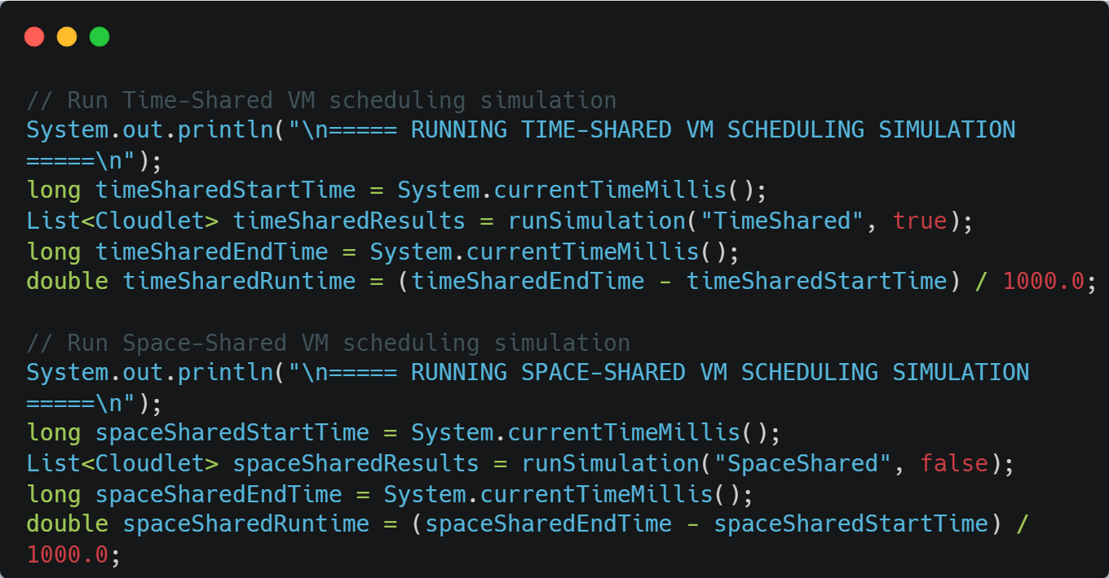

This part of the code runs two separate simulations—one using **TimeShared** and the other using **SpaceShared** VM scheduling. It records the start and end time of each simulation using System.currentTimeMillis() to calculate how long each one takes to complete. The results of both runs are stored for later comparison in terms of performance and efficiency.

**Step 2: Create VMs**

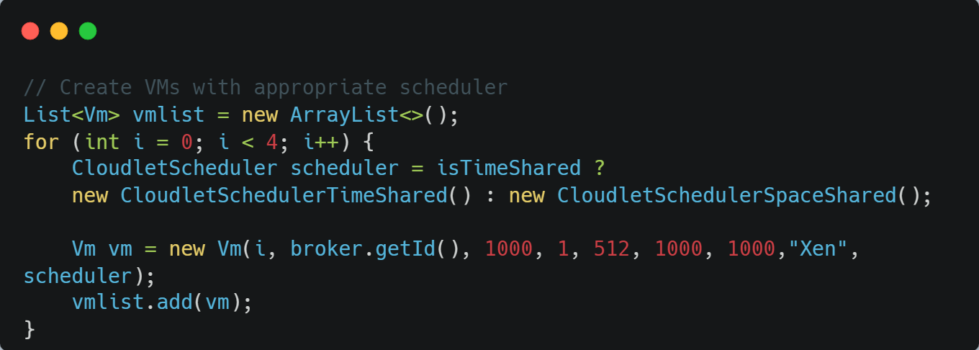

This part of the code creates a list of Virtual Machines (VMs) and assigns a scheduling strategy to each one based on the simulation mode. It runs a loop to create 4 VMs, and for each VM, it selects either **TimeShared** or **SpaceShared** scheduling depending on the isTimeShared flag. Each VM is given fixed configurations such as 1000 MIPS, 512 MB RAM, and 1000 MB storage, and then added to the VM list to be submitted for simulation.

**Step 3:Create Cloudlets**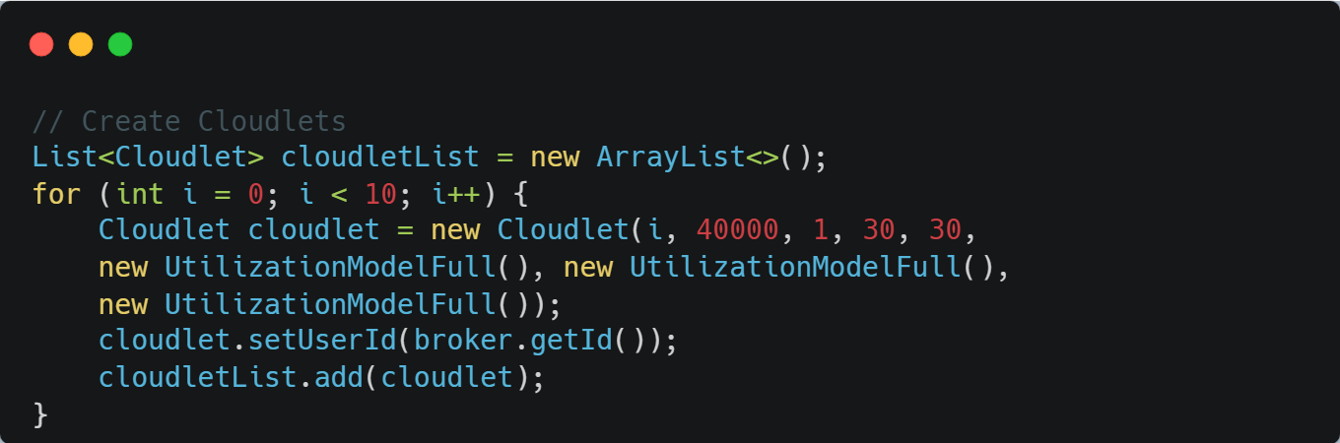

This code creates a list of 10 cloudlets, each with a length of 40,000 instructions and resource requirements of 30 units. Each cloudlet is assigned full CPU, memory, and bandwidth usage, and a user ID from the broker. The cloudlets are then added to the cloudletList.

**Step 4: Create Datacenter**

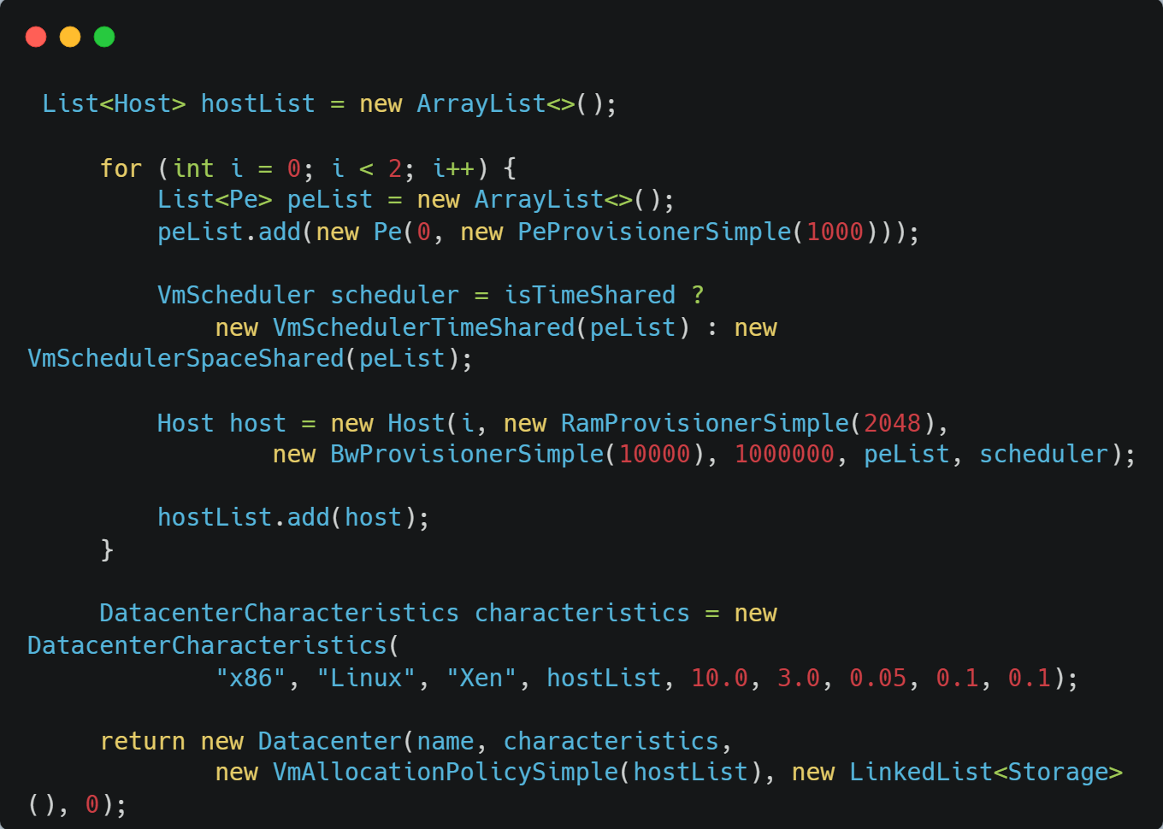

This code creates a list of two hosts for a cloud data center. Each host is configured with a processor (Pe), a memory provisioner, a bandwidth provisioner, and a VM scheduler (either time-shared or space-shared based on the isTimeShared flag). The hosts are then added to hostList. Next, the DatacenterCharacteristics are defined, specifying details like architecture, operating system, hypervisor, and host list. Finally, a new Datacenter is created using these characteristics, a simple VM allocation policy, and no storage, and it is returned.

**Step 5: Calculate Max Finish Time**

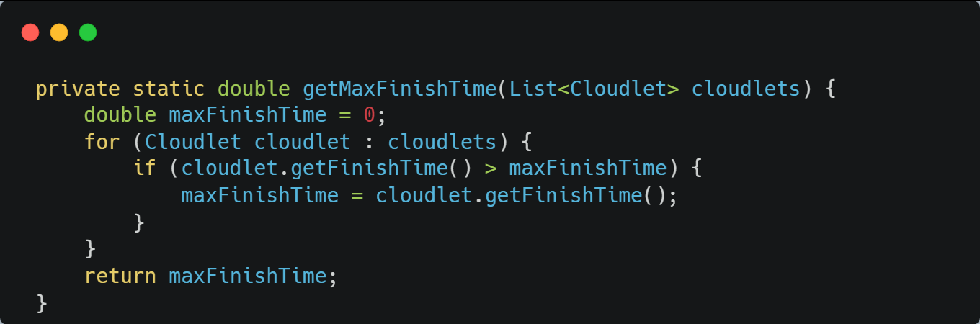

This method calculates the maximum finish time from a list of cloudlets. It initializes maxFinishTime to 0, then iterates over each cloudlet in the list. For each cloudlet, it checks if its finish time is greater than the current maxFinishTime. If so, it updates maxFinishTime with the new value. Finally, the method returns the highest finish time found among all cloudlets.

**Step 5: Calculate Average Execution Time**

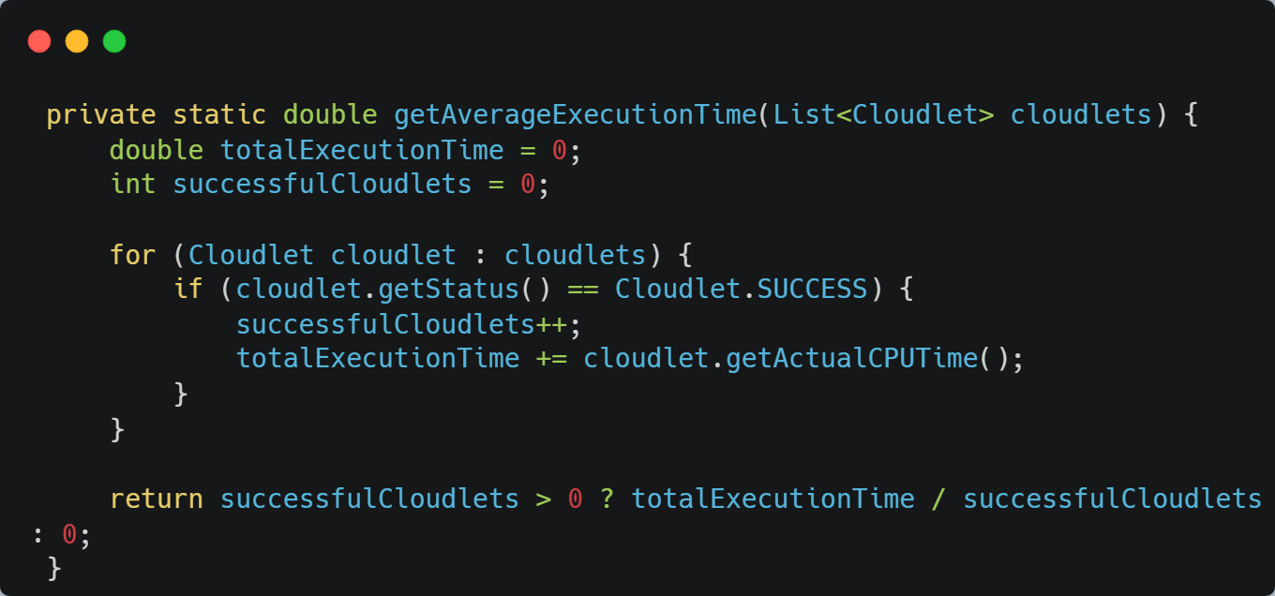

This method calculates the average execution time of successful cloudlets from a list. It initializes totalExecutionTime to 0 and successfulCloudlets to count the cloudlets that completed successfully. It then iterates over the cloudlets, adding the actual CPU time of each successful cloudlet to totalExecutionTime and incrementing the successfulCloudlets counter. After the loop, it returns the average execution time by dividing totalExecutionTime by the number of successful cloudlets. If there are no successful cloudlets, it returns 0.

## **CI/CD Pipeline Implementation**

* .yml workflow runs automatically on **push to main branch**
* Workflow steps:
  + Set up Java 11
  + Compile simulation code
  + Run the simulation
* Output is visible in **Actions tab**, ensuring:
* **Automation**
* **Consistency**
* **Error checking** on every code update

## **Benefits of CI/CD Implementation**

* Reduced manual deployment effort
* Consistent build and test environment
* Faster release cycles
* Better code quality through automated testing
* Enhanced team collaboration

## **Conclusion**

The project successfully simulated and compared two VM allocation strategies using CloudSim:

* **TimeShared (Round Robin)** allows better CPU sharing but causes tasks to complete at the same time
* **SpaceShared (FCFS)** executes tasks faster individually but sequentially, leading to a similar overall time

The use of **GitHub Actions** enabled full CI/CD automation, providing a modern development pipeline.

## **Future Scope**

* Add support for dynamic resource scaling
* Visualize results using graphs or charts
* Export results to CSV or PDF
* Add a simple frontend (JavaFX / Spring Boot + HTML)